(Capstone Project 2)

Sentiment Analysis of E-commerce Product
Domain: E-commerce
Prepared By: Prakash Patel
https://github.com/PrakashPatel8979/Capstone-project-2-Sentiment-Analysis-of-E-commerce-

1. Introduction
This project focuses on sentiment analysis of e-commerce product reviews. The objective is to classify customer reviews into Positive, Negative, and Neutral categories. The dataset contains review text, brand information, product categories, and sentiment labels. The project implements traditional machine learning models as well as deep learning approaches.

2. Objectives
- Understand sentiment expressed in customer reviews.
- Handle class imbalance problem.
- Implement machine learning classifiers.
- Compare traditional ML models with deep learning models.
- Perform topic modeling to extract hidden themes.

3. Exploratory Data Analysis (EDA)
Exploratory Data Analysis was performed to understand sentiment distribution, review length distribution, and class imbalance. The dataset showed a higher number of positive reviews compared to negative and neutral reviews.
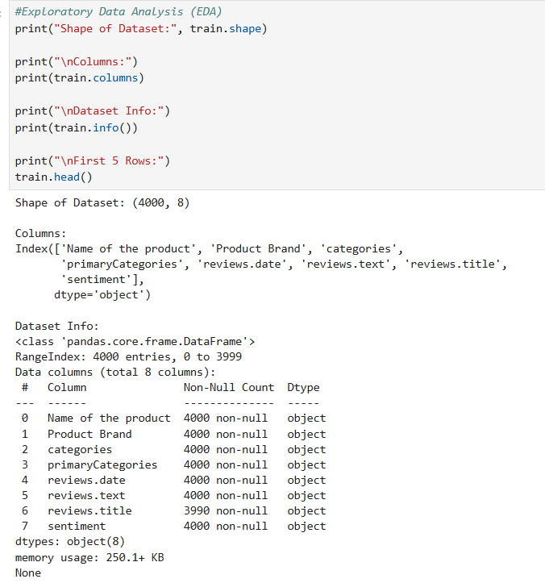

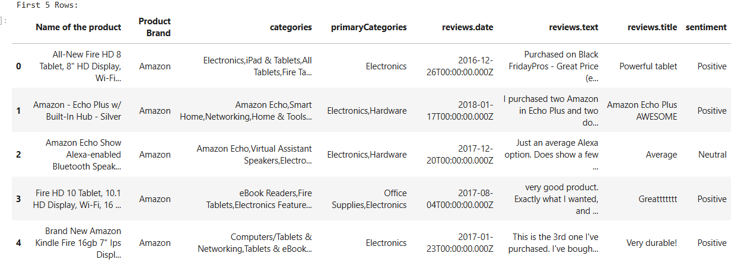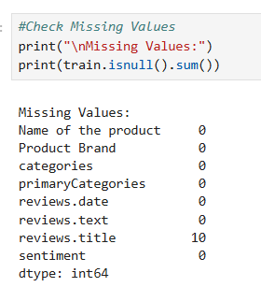
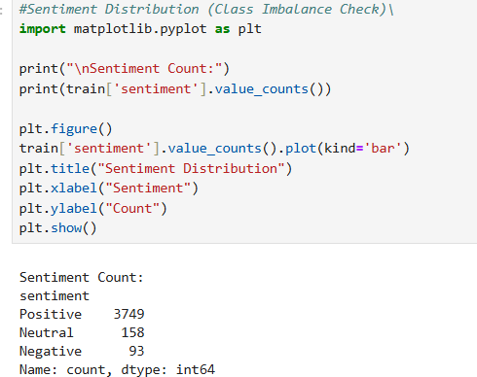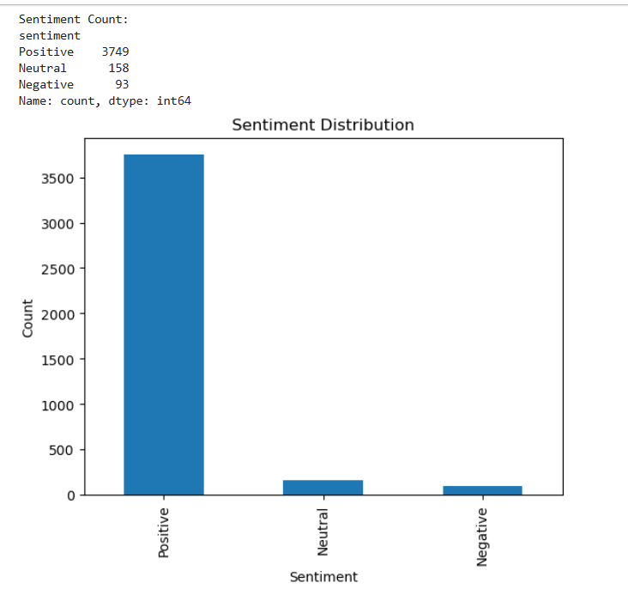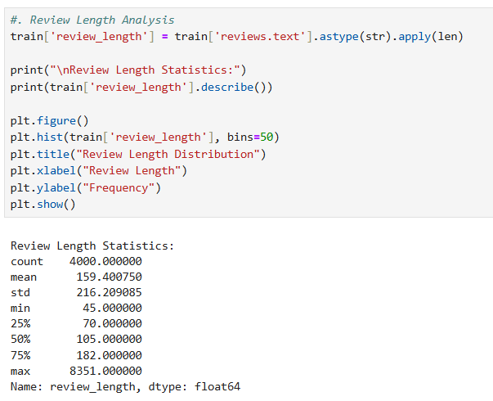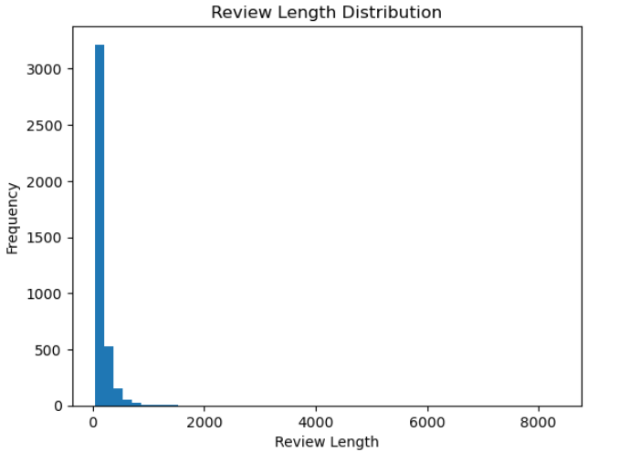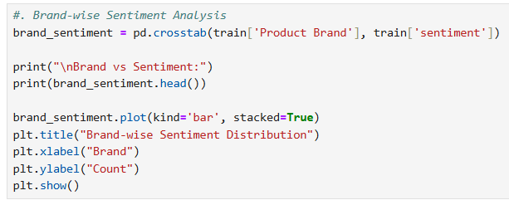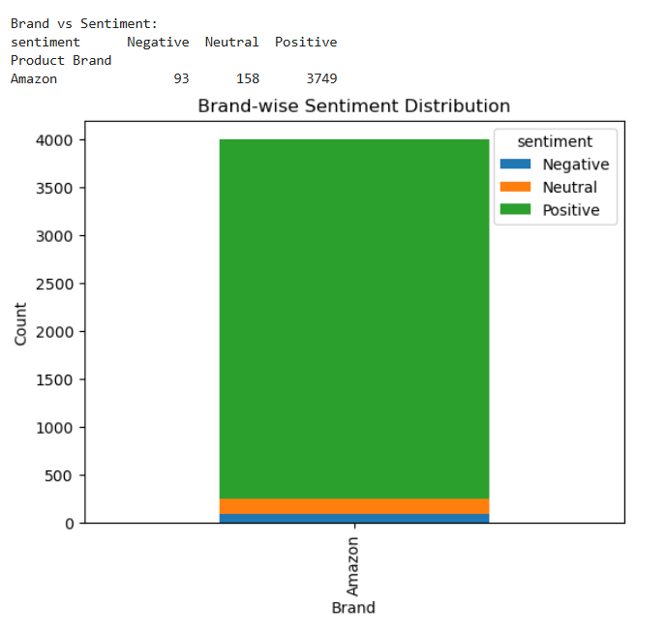
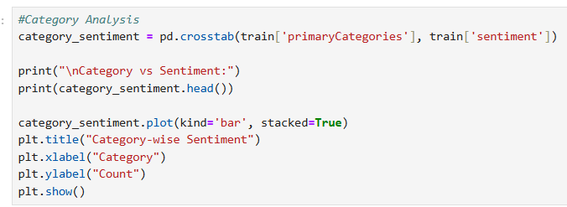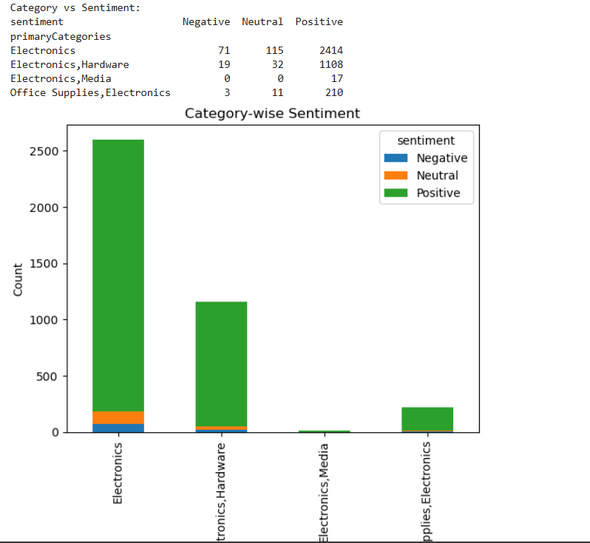
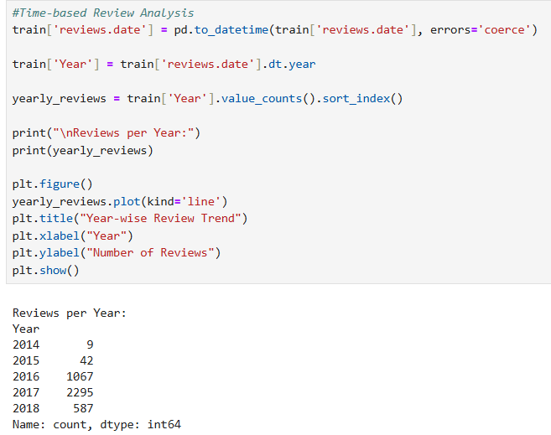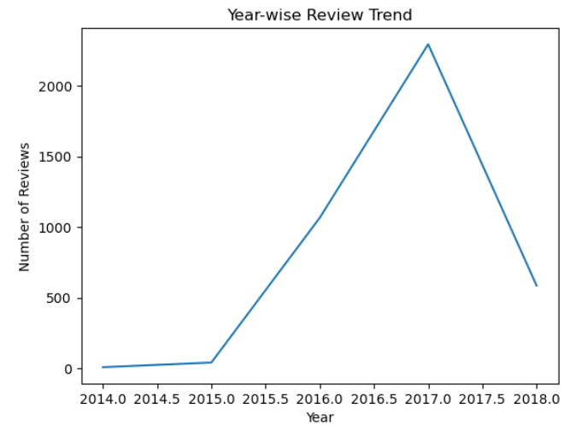

4. Feature Engineering
Text preprocessing techniques such as lowercasing, stopword removal, and lemmatization were applied. TF-IDF vectorization was used to convert text into numerical features. SMOTE was applied to address class imbalance.
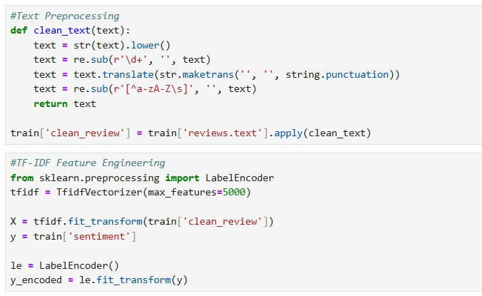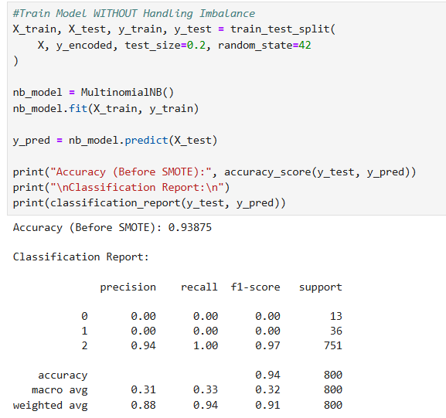
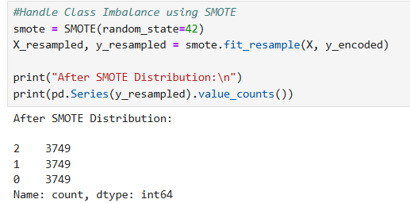
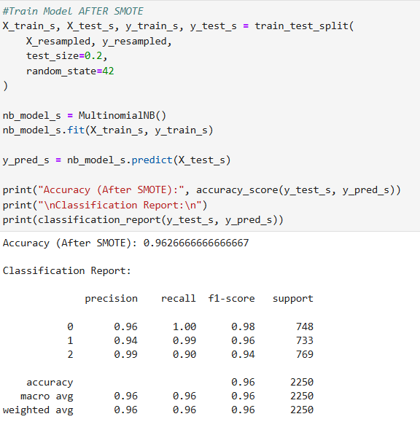

5. Models Implemented
- Multinomial Naive Bayes
- Support Vector Machine (SVM)
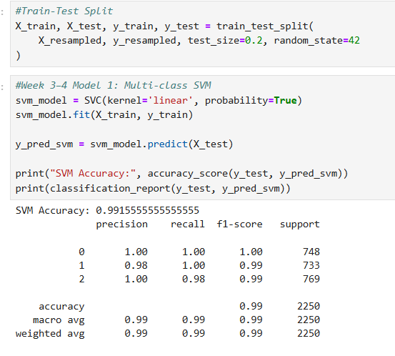
- XGBoost Classifier
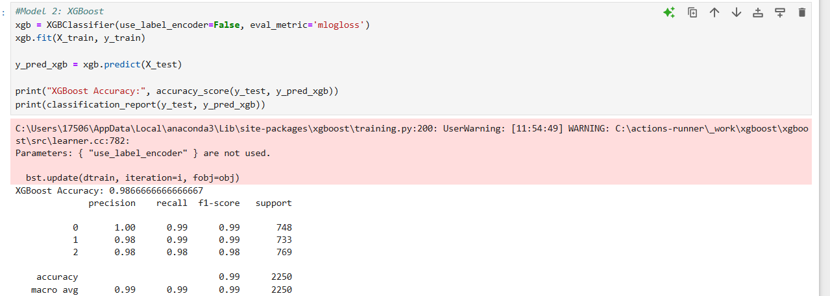

- LSTM (Long Short-Term Memory Network)

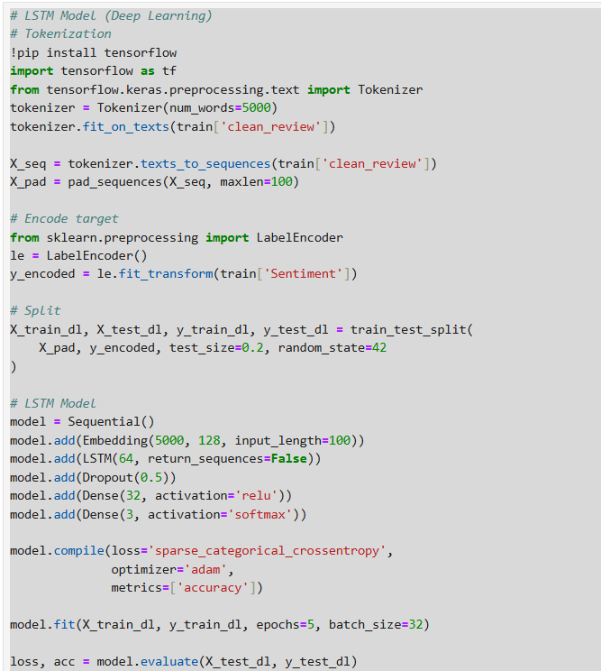
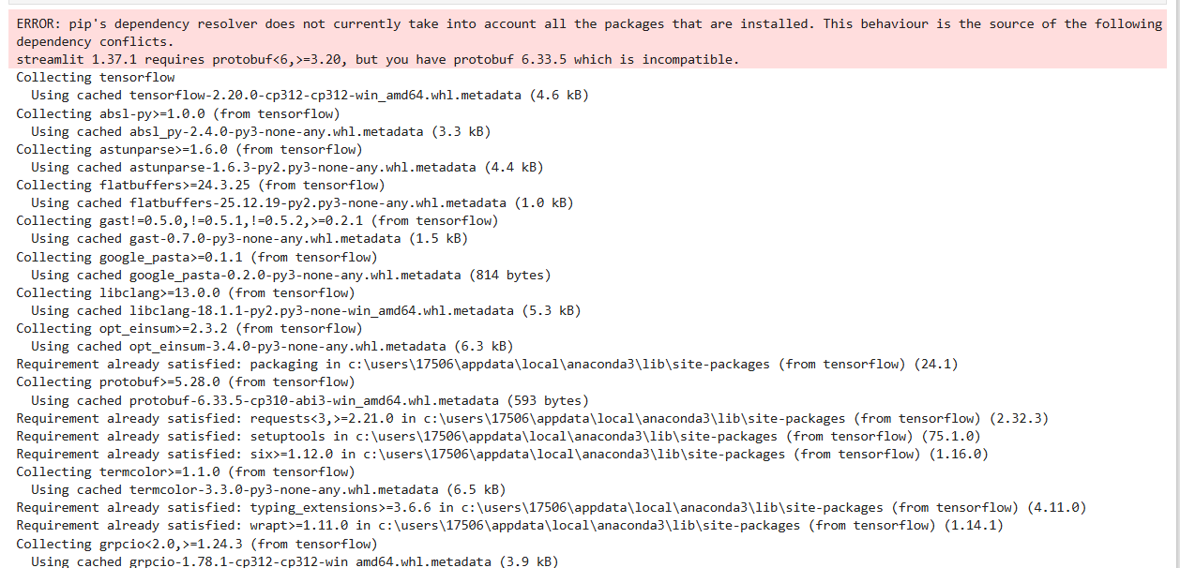

6. Evaluation Metrics
- Accuracy
- Precision
- Recall
- F1-Score
- Confusion Matrix
- ROC-AUC Score

7. Topic Modeling
Latent Dirichlet Allocation (LDA) was used to identify hidden topics within customer reviews. The topics helped group reviews based on product features, performance, and quality aspects.
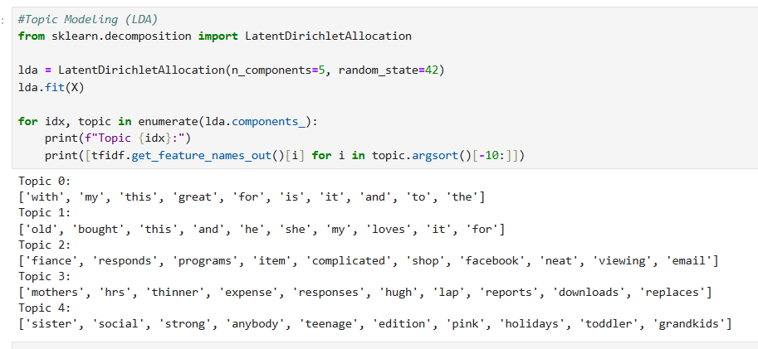

8. Results & Comparison
Traditional machine learning models performed well on structured TF-IDF features. Among ML models, SVM achieved strong performance. The LSTM model captured sequential dependencies in text and provided competitive accuracy. Handling class imbalance significantly improved minority class prediction.

9. Conclusion
This project demonstrates the implementation of sentiment analysis using both machine learning and deep learning techniques. Addressing class imbalance, performing feature engineering, and applying optimization techniques resulted in improved predictive performance. The project provides practical exposure to real-world NLP applications.

10. Learning Outcomes
- Understanding of NLP preprocessing techniques
- Handling class imbalance problems
- Implementation of ML and Deep Learning models
- Model evaluation and comparison
- Topic modeling for text clustering

Thank You

